**Social Media Marketing**

**Week 5: Social Media Analytics & Reporting**

**Submitted by: Iqra Tariq**

**Objective: Learn how to track and measure social media performance.**

**Task 1:** List **10 key social media metrics** and explain each (reach, impressions, CTR, CPC, etc.).

Effective Social Media Marketing relies on measuring key performance indicators (KPIs) to gauge success and make data-driven decisions.

Tracking Social Media Marketing KPIs offers businesses valuable insights and advantages. Firstly, it enables businesses to measure the effectiveness of their campaigns and strategies.

**Top 10 KPIs and success metrics for Social Media Marketing**

**1. Engagement Rate**

Engagement Rate measures the level of interaction and involvement generated by social media content. It helps assess the effectiveness of content in capturing the audience's attention and fostering meaningful connections.

How to get this KPI:

* Sprout Social
* Hootsuite
* Buffer

Other tools like Veed can help you optimize your social media engagement rate. It allows you to [convert any type of media](https://www.veed.io/convert/video-converter), such as [MP4 to MP3](https://www.veed.io/convert/mp4-to-mp3), and offers an [MP3 converter](https://www.veed.io/convert/mp3-converter) for audio-only content.

**2. Reach**

Reach measures the total number of unique users or accounts exposed to a social media post or campaign. It indicates the potential audience size and helps evaluate the impact and visibility of social media efforts.

How to get this KPI:

* Sprout Social
* Hootsuite
* Buffer

**3. Click-through Rate (CTR)**

Click-through Rate calculates the percentage of users who click on a specific link or call-to-action within a social media post or ad. It helps measure the effectiveness of content in driving traffic and directing users to desired destinations.

How to get this KPI:

* Sprout Social
* Hootsuite
* Buffer

**4. Conversion Rate**

Conversion Rate measures the percentage of social media users who complete a desired action, such as making a purchase or filling out a form. It helps evaluate the effectiveness of social media campaigns in driving conversions and achieving business goals.

How to get this KPI:

* Sprout Social
* Hootsuite
* Buffer

**5. Customer Sentiment**

Customer Sentiment measures the sentiment or emotional tone expressed by social media users towards a brand or its products/services. It helps gauge brand reputation, customer satisfaction, and identify areas for improvement or further engagement.

How to get this KPI:

* Sprout Social
* Brand watch
* Mention

**6. Share of Voice (SOV)**

Share of Voice quantifies a brand's presence and visibility compared to its competitors within social media conversations. It helps assess brand awareness, market share, and the effectiveness of social media strategies.

How to get this KPI:

* Sprout Social
* Brand watch
* Mention

**7. Follower Growth Rate**

Follower Growth Rate measures the percentage increase in social media followers over a specific period. It helps evaluate the growth and popularity of social media accounts, indicating the effectiveness of content and engagement strategies.

How to get this KPI:

* Sprout Social
* Hootsuite
* Buffer

**8. Social Media Mentions**

Social Media Mentions count the number of times a brand or specific keywords related to the brand are mentioned across social media platforms. It helps monitor brand visibility, track brand sentiment, and identify opportunities for engagement.

How to get this KPI:

* Sprout Social
* Brand watch
* Mention

**9. Cost per Click (CPC)**

CPC (cost per click) is a metric that determines how much advertisers pay for the ads they place on websites or social media, based on the number of clicks the ad receives. CPC, also called PPC or pay per click, is important for marketers to consider, since it measures the price for a brand’s paid advertising campaigns.

**10. Return on Ad Spend (ROAS)**

Return on Ad Spend measures the revenue generated in comparison to the cost of social media advertising campaigns. It helps evaluate the profitability and effectiveness of ad campaigns in driving sales and achieving business goals.

How to get this KPI:

* Sprout Social
* Hootsuite
* Buffer

**Task 2:** Perform a **performance analysis of 3 competitor pages** (post frequency, average likes, comments).

|  |  |  |  |  |  |
| --- | --- | --- | --- | --- | --- |
| Brand | Post Frequency (weekly avg) | |  | | --- | |  |  |  | | --- | | Avg Likes per Post | | Avg Comments per Post |
| Sapphire | 6–7 posts/week | 3,500–5,000 | 50–70 |
| Nishat Linen | 4–5 posts/week | 1,500–2,500 | 20–35 |
| Limelight | 5–6 posts/week | 2,000–3,000 | 25–40 |

**Task 3:** Create a **weekly analytics report template** in Google Sheets or Excel.

1. **Weekly Summary:**

|  |  |  |  |  |  |  |  |  |  |  |  |  |  |
| --- | --- | --- | --- | --- | --- | --- | --- | --- | --- | --- | --- | --- | --- |
| |  |  | | --- | --- | | **Metric** | **Value** | | Followers Gained |  | | Posts Published |  | | Total Reach |  | | Engagement Rate |  | | Top Post |  | |  |
|  |  |
|  |  |
|  |  |

**2  
Post-by-Post Performance**  
| Date | Post Caption | Platform | Reach | Likes | Comments | Shares | CTR (%) |

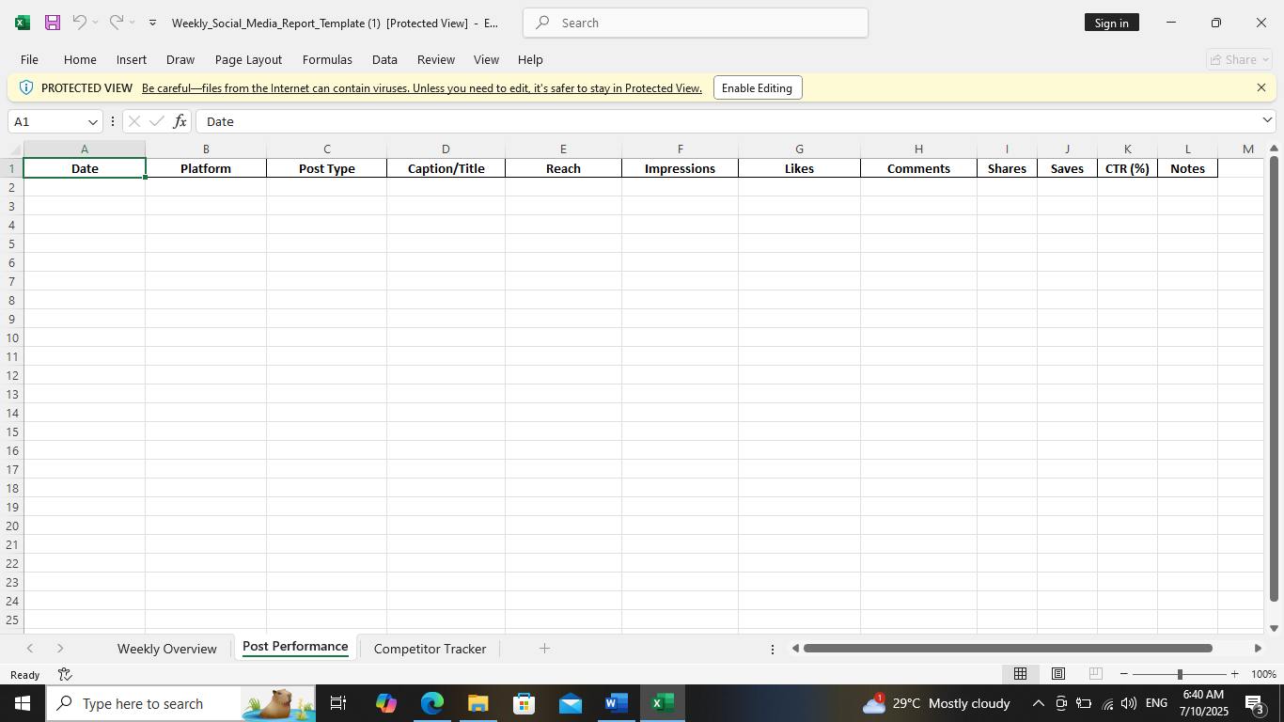

1. **Competitor Comparison**   
   | Competitor | Posts | Avg Likes | Avg Comments |

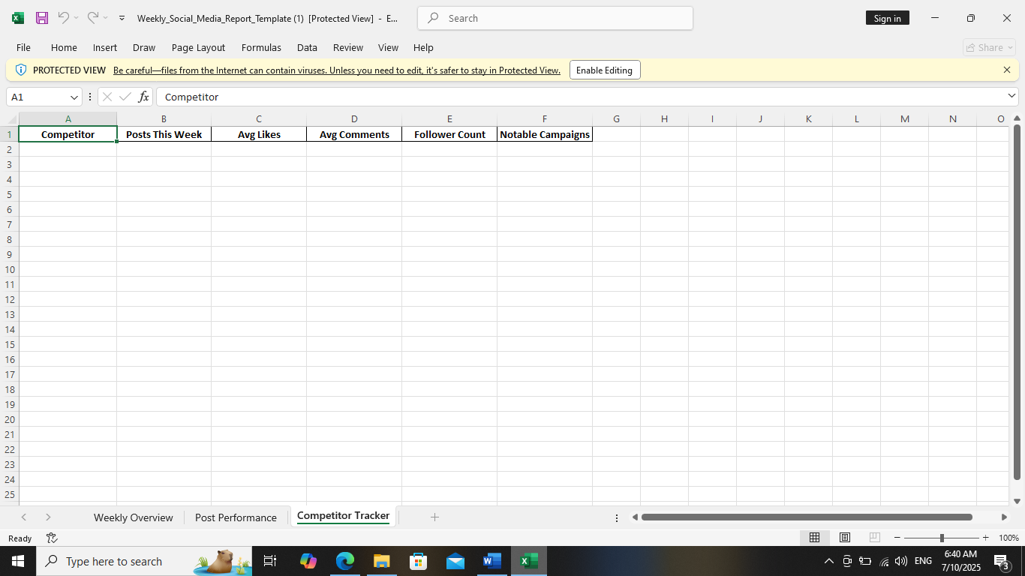

**Task 4:** Study and summarize **how Instagram Insights and Facebook Analytics work** (250-300 words).

Social media analytics is all about collecting data from social media platforms and leveraging that information to make better, more intentional decisions for your organization. Consulting your Facebook and Instagram analytics regularly helps you understand how to use these platforms as a part of your marketing strategy, so your organization can grow and thrive.

Instagram and Facebook analytics are the **metrics used to understand how content performs on Instagram and Facebook.** They help you understand your audience and their preferences, and allow you to create strategies based on data rather than creative hunches.

Instagram analytics data can range from very basic (like how many people saw or liked an individual post) to very specific (like what time your account’s followers are most likely to be online). Examples of Instagram analytics metrics include impressions, likes, shares, and audience growth over time.

Social media managers often dread the part of their job that has to do with tracking data and building reports. We get it, it’s not as fun as creating content and interacting with followers. But try to think about Instagram analytics and Facebook insights as a fascinating puzzle. Solving it can help you improve your overall results over time and prove the value of your work to your boss and larger team.

With Instagram analytics and Facebook Insights, you can also:

* Understand your audience.
* Grow your account faster.
* Report with confidence.

Instagram analytics and Facebook Insights data is most useful when it’s compiled into a report that allows you to compare results and spot trends. If you’d rather get your Instagram analytics reports automatically, check out the Instagram analytics built into Hootsuite. The Instagram Insights and Facebook Analytics, allow you to automatically report on engagement, your audience, or post-performance.

**Task 5:** Suggest **3 strategies to improve low engagement rates** on social media posts.

**Strategies to Improve Your Social Media Engagement Rate**

* Focus on the Right Metrics

Start by analyzing your social media engagement metrics. What’s your current engagement rate? Which types of posts get the most reactions? Platforms like Instagram Insights or tools like Google Analytics can show you what’s working and where to improve.

* Tailor Content for Each Social Channel

Different platforms have different audiences. TikTok is great for short, trendy videos, while LinkedIn is ideal for professional insights. Crafting content specific to each social channel increases engagement.

* Interactive Content Is Key

Boost engagement by encouraging interaction. Polls, quizzes, and Q&A sessions are great for sparking conversations. People love being part of the story.

**Create a Social Media Engagement Strategy**

* Post Consistently

Posting sporadically makes it hard to build momentum. Plan your content calendar ahead of time, ensuring a steady flow of posts tailored to your audience.

* Optimize Your Content

Pay attention to visuals, captions, and timing. Eye-catching images or videos paired with concise, action-oriented captions perform best. Use analytics to find the best posting times for your audience.

* Engage With Your Followers

Remember, social media is a two-way street. Reply to comments, answer DMs, and like or share your followers’ posts. Genuine interactions show your audience that you care.